**WEEK – 3  
ASSIGNMENT**

If-else:

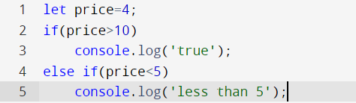

Ternary Operator:

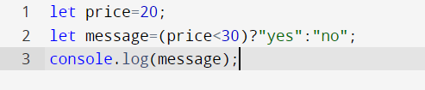

For Loop:

While Loop:

Do While Loop:

Function:

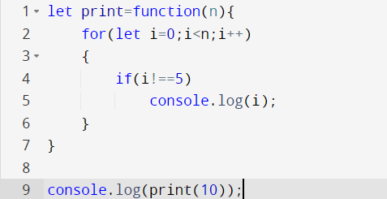

Function Return:

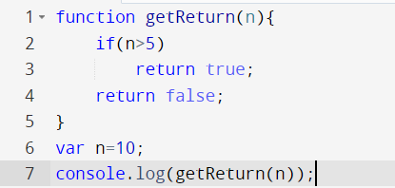

Object methods:

Passing Objects to Function:

DOM:

Array:

//push

//pop

//shift

//unshift

//slice

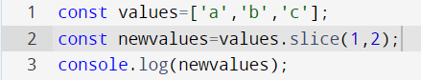

//splice

//filter

//find

//for Each

Switch:

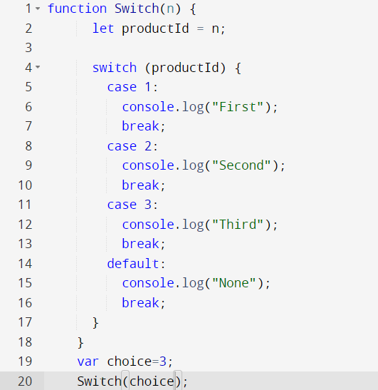

For/in:

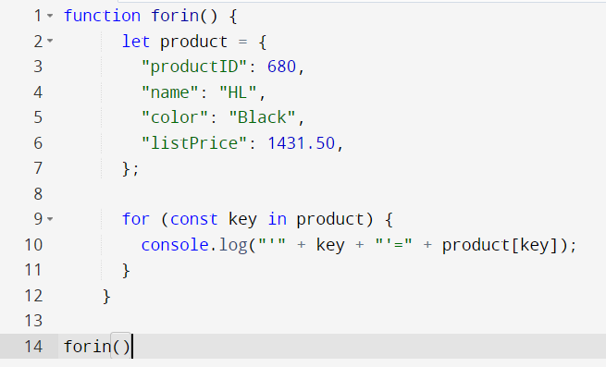

For/of:

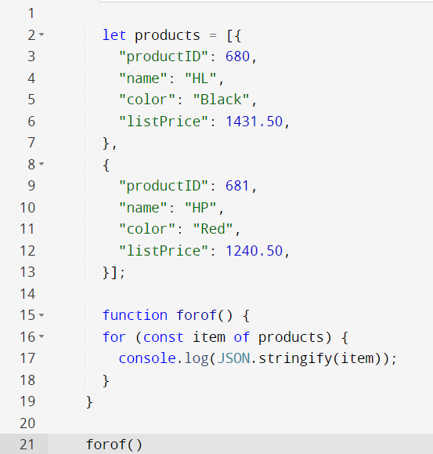

Loop in String:

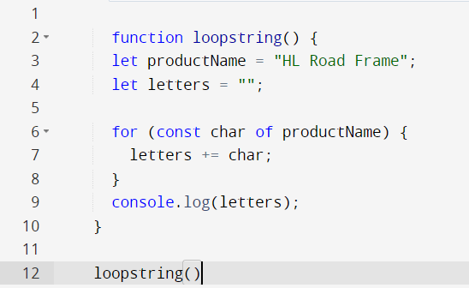

Exception Handling:

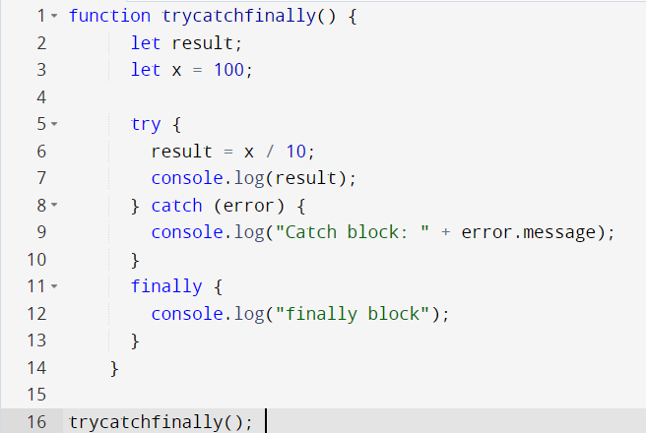

String to Array:

Remove Duplicates:

Copy an Array:

